ELA C.E.R.J RUBRIC
Element | 4 | 3 | 2 | 1 | 0
Claim  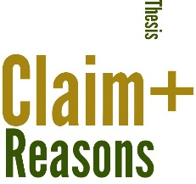 | *Claim statement is clear  *Includes all of the necessary parts of the question in the answer (IQIA)  *Gives a clear answer  *Includes a brief because statement | *Claim statement is clear  *Includes part of the question in the answer (IQIA)  *Gives a clear answer | *Claim statement is unclear  *Repeats an inadequate portion of the question  *A partial answer is given  *Includes personal pronouns (I, we, etc.) | *Does not repeat part of the question in the statement | *No claim statement is written  *Incorrectly answers prompt
Evidence  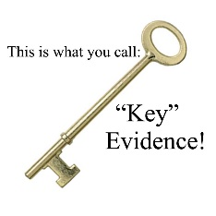 | *Quotes strongly support the claim statement  *Quotes are smoothly incorporated  *Quotes are correctly “cited” (3). | *Quotes support the claim statement  *Quotes are incorporated  Quotes are incorrectly cited | *Quotes partially support the claim  *Quotes are not incorporated  *Quotes are not cited | *Evidence is written as a paraphrased summary of examples | *No evidence is given  *Evidence does not support claim
Reasoning/Justification  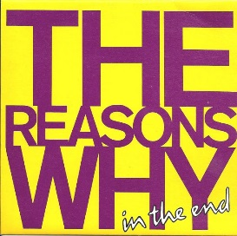 | *Explanation is given between quotes if more than one quote is included  *Explanation strongly draws connections between the evidence and the claim or further explains the evidence and claim  *Explains why the information matters and is important (without being formulaic)  *Explanation goes beyond what is stated in the quotes | *Explanation is given between quotes if more than one quote is included  *Explanation draws connections between the evidence and the claim or further explains the evidence and claim  *Explains why the information matters and why it is important (formulaically) | *Explanation draws vague connections between evidence and claim or partially explains why the information matters or why it is important | *Has only a weak conclusion that does not add any explanation or reasoning  *Conclusion uses circular reasoning (this is important because it is important) | *Does not provide any further explanation or reasoning

